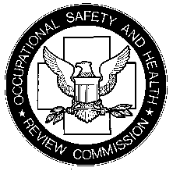

United States of America
OCCUPATIONAL SAFETY AND HEALTH REVIEW COMMISSION
1120 20th Street, N.W., Ninth Floor
Washington, DC 20036-3457

SECRETARY OF LABOR,
Complainant,
v. | OSHRC DOCKET NO.
XYZ CORP.,
Respondent.

DIRECTION FOR REVIEW
Pursuant to 29 U.S.C. § 66(j) and 29 C.F.R. § 2200.92(a), the report of the Administration Law Judge is directed for review. A briefing order will follow.

COMMISSIONER
Dated:

