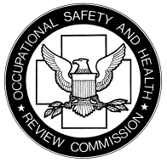
OCCUPATIONAL SAFETY AND HEALTH REVIEW COMMISSION
1120 20th Street, N.W., Ninth Floor
Washington, DC 20036-3457

Office of Chief Judge Phone: 202-606-5405

NOTICE OF APPLICATION OF REVISED OSHRC RULES TO THIS CASE

Pursuant to 84 Fed. Reg. 14554 (April 10, 2019), the Review Commission’s revised rules will take effect on June 10, 2019. They apply to all cases docketed on or after that date.

They also apply to proceedings in cases pending on that date, except to the extent that their application would be infeasible or would work an injustice, in which event the present rules apply.

It is advised that you familiarize yourself with the revised Rules. The revised Rules may be accessed by visiting:

https://www.govinfo.gov/content/pkg/FR-2019-04-10/pdf/2019-06581.pdf

